Creating/Running a Batch Input Process

In the next step, you process the batch input session. You now post the accounting documents you created earlier and stored in the batch input session.

TRANSACTION CODE SM35

ACCESS PATH SAP Easy Access screen on the top click
System → Services → Batch Input → Sessions/Edit

The system displays on the Batch Input: Session Overview screen a list of batch input sessions.

Click Push Button – New

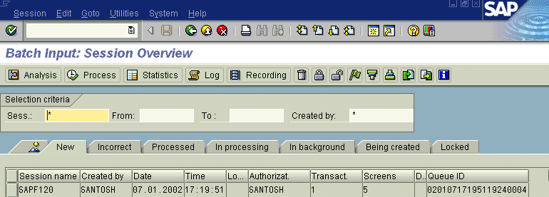
We get the screen as under

Mark the batch input session to be processed by positioning the cursor on the appropriate line

Select Process session.

The System displays a Screen as under

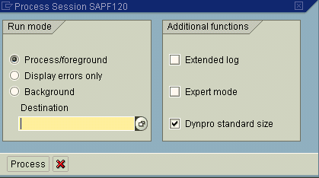
Mark Process/foreground, if you want to release each processing step or in Background.

Releasing each processing step enables you to make changes if necessary.

Select Process.

Confirm each step by selecting Enter.

You can ignore any warnings regarding the next scheduled run, net due date, and payment conditions by selecting Enter.

When the system displays the message "Batch input processing completed", select Exit.

The system posts all recurring documents in your batch input session.

Return to the main screen.

